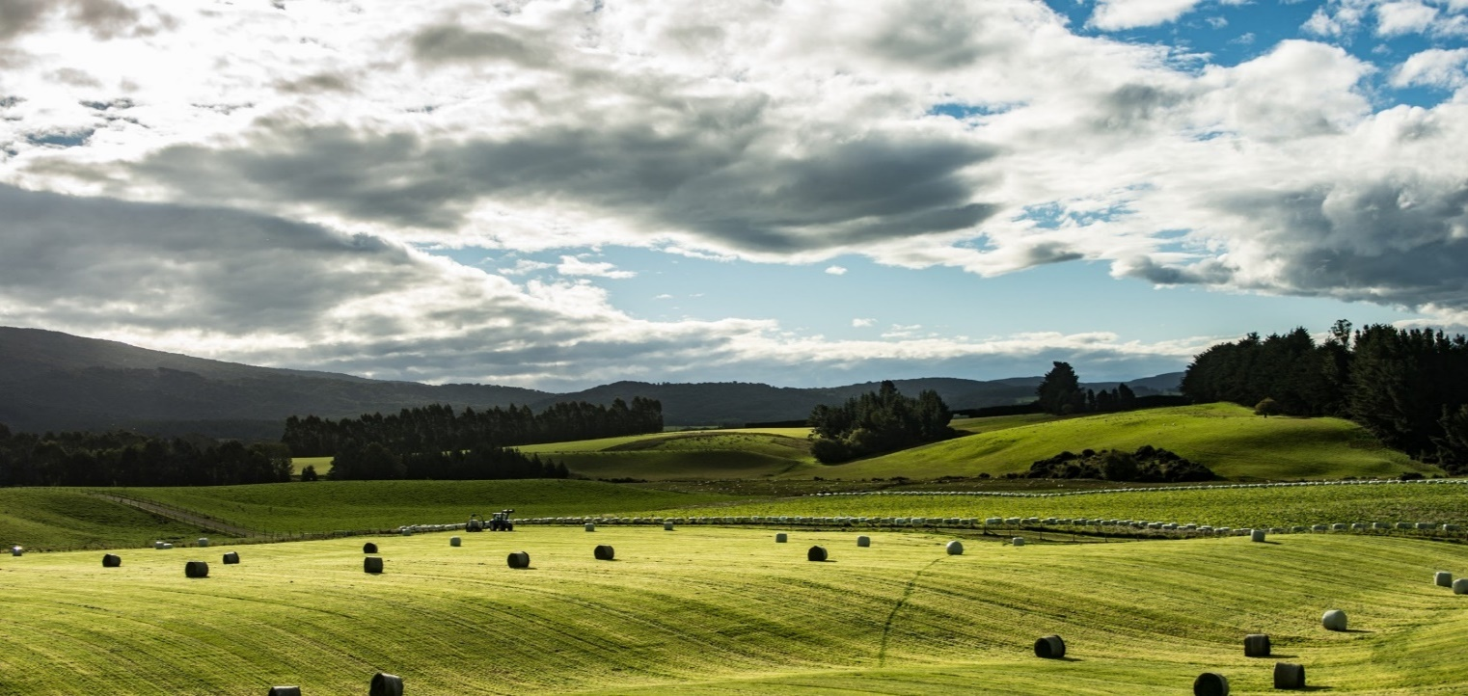

**Intensive Winter Grazing Management Plan**

How this Winter Grazing Plan can help you

* It creates clear expectations for everyone on the farm as to how wintering will be done
* It identifies areas for improvement
* It provides proof of good practice (including council, your product buyers, and your farm team)

An effective wintering system:

* supports good animal health and welfare
* minimises soil and nutrient loss to the environment, and protects valuable topsoil
* complies with regional council regulations
* complements the overall farm system and the farm team’s work
* has a contingency plan for periods of adverse weather

For further information on the Government’s winter grazing regulations, see

[***https://environment.govt.nz/acts-and-regulations/freshwater-implementation-guidance/intensive-winter-grazing/***](https://environment.govt.nz/acts-and-regulations/freshwater-implementation-guidance/intensive-winter-grazing/)

Resources to help you plan your approach to wintering

* DairyNZ – Break Fed Wintering guide at [www.dairynz.co.nz/wintering](http://www.dairynz.co.nz/wintering)
* Beef and Lamb NZ – Winter grazing site at [www.beeflambnz.com/wintergrazing](http://www.beeflambnz.com/wintergrazing)
* MPI – [Animal management: Winter grazing and mud](Action%20Group%20report%20on%20short%20term%20animal%20welfare%20expectations%20at%20www.mpi.govt.nz,%20search%20for%20‘winter%20grazing%20action%20group%20animal%20welfare’)
* MPI - Codes of welfare for dairy cattle, sheep, beef cattle and deer at [www.mpi.govt.nz/welfarecodes](http://www.mpi.govt.nz/welfarecodes)

***If you would like more help with your planning, please contact our Otago Regional Council Catchment Advisor team on*** [***catchments@orc.govt.nz***](mailto:catchments@orc.govt.nz) ***or ring 0800 474 082 See*** [***https://www.orc.govt.nz/managing-our-environment/water/good-practice-information/intensive-winter-grazing***](https://www.orc.govt.nz/managing-our-environment/water/good-practice-information/intensive-winter-grazing) ***.***

***You can also contact your local industry body representative.***

## Critical source areas (CSAs)

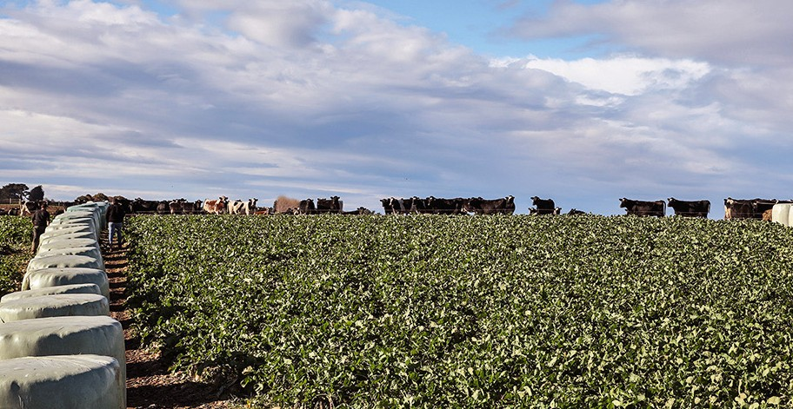

Planning your winter grazing

Wintering tips from farmers on areas to focus on

Photo credit: DairyNZ

CSAs are landscape features such as gullies, swales or depressions that accumulate runoff from adjacent areas and deliver it to surface waterways (streams, rivers, lakes, and wetlands). Nutrients can pool and get into waterways or groundwater from these areas.

**FARMER TIP**

*“I mark these out prior to sowing to ensure they are not cultivated and fence them off with a semi-permanent fence (waratahs and poly wire) at the start of the winter. If in doubt about where to fence, I fence off a bigger area.”*

## Direction of grazing

*Planning the direction of your grazing can reduce mud levels, creating a better environment for cows and reducing nutrient and sediment loss.*

**FARMER TIPS**

*“Where practical I graze towards Critical Source Areas and waterways. If this is not possible, I leave a large buffer (at least 25m) and graze away. I graze the buffer last.”*

*“We winter our sheep in blocks and shift them every 4 days. We find that the sheep are more content and there is less soil damage with the longer grazing periods provided the yields are adequate. We check the sheep every two days to ensure feeding levels are adequate.”*

## Bale placement

Well considered bale placement can reduce mud in the paddock, reduce how much time stock spend around waterways and Critical Source Areas, and reduce workload for your team.

**FARMER TIP**

*“I keep baleage away from swales and waterways. I also think about how far my team have to carry baleage wrap out of the paddock.”*

## Portable troughs and back fences

A back fence and portable trough will reduce cow movements and therefore limit soil damage through unnecessary stock movement.

**FARMER TIPS**

*“I put my portable trough and pipes along the side fence. This keeps the pipes away from stock and means that we aren’t moving them through muddy paddocks.”*

*“Back fences have been a game changer for us. Although it is another job to do, it means that all the stock are up at the feed face which saves energy, and if we need to get them out of the paddock, the back fence makes this much easier.”*

*“We have found that back fences reduce soil damage. Less soil damage means less groundwork and better new grass”*

## Planning for the weather

Winter weather can play havoc with paddocks, so having a Plan B, and knowing when to implement it, is critical.

**FARMER TIPS**

*“We have a few areas planted in crop that are sheltered. We use these areas for any mobs that need more care – lighter younger or multiples. The shelter dramatically reduces the energy required to stay warm. Since doing this, we have found that ewes finish winter in a much more even state and are well prepared for lambing.”*

*“We winter on fodder beet. It is too difficult and risky to change the diet, so in poor weather we create a straw bale fence using 4 or 5 bales. This gives the stock shelter, and they lie down in the straw warm and comfortable until the weather passes.”*

## Animal welfare

**FARMER TIP**

Planning in advance with your team how you will check up on stock, and what to look for helps ensure everyone is on the same page.

“We check our stock each day to make sure they healthy and well fed. If a team member sees an animal with sunken eyes or poor gut fill, we go back and check it later in the day and take them off crop. We aim to notice that the animal is sick before she notices it herself.“

## Time efficiency

Forward planning can save time over winter and help protect your stock.

As a team, we create the ‘master plan’ on a big farm map, which includes transitioning, animal welfare and environmental risk management. Any paddocks that are a bit more complex or have a different wet weather plan, we later draw individually to make sure CSAs and waterways are protected.”

# SECTION A: Paddock Map - Example One

# There are multiple ways you can do a wintering paddock map including hand-drawn, drawing over top of aerial images or using existing online mapping programmes. Here are two examples:

**Paddock Description:** Paddock 8,100 cows, mid calvers, fat condition

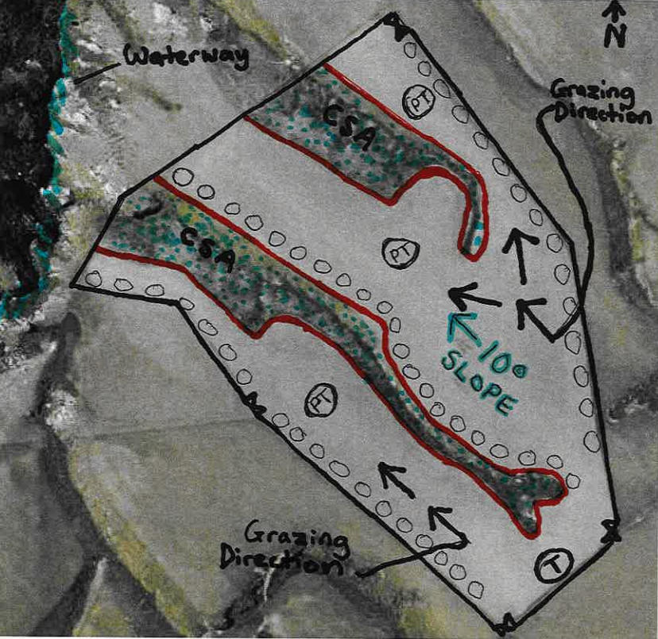**Crop type:** Kale and baleage (8m crop and 2 bales)

# Paddock Map - Example Two

|  |
| --- |
| **slope 10°** |

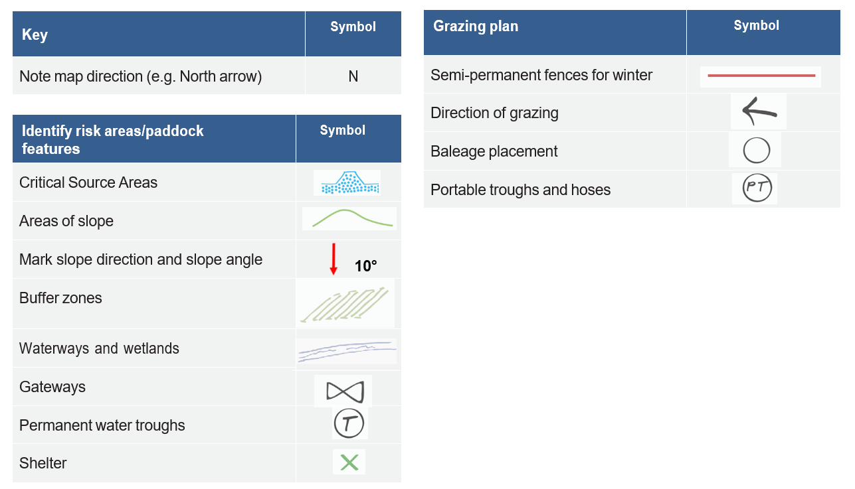

|  |  |  |
| --- | --- | --- |
| **Farm name:** | **Person in charge:** | |
| **Property Address:** | | |
| **Farm area (ha):** | **Wintering area (ha):** | **Number of wintering paddocks:** |

# SECTION B: Overall Management Approach

# The purpose of this section is for you to think about your overall management approach to intensive winter grazing.

| **Environmental Risk Management** | **Example** | **Your Actions** |
| --- | --- | --- |
| What is your cultivation method? | *I use direct drilling to minimise soil disturbance and cultivate across the contour to reduce the risk of sediment runoff.* |  |
| What is your grazing strategy? | *I will graze downhill, utilising wide breaks, with the last bite being closest to the waterway.* |  |
| How will you manage supplementary feed and water trough placement? | *Supplementary feed will be fed in the drier areas of the paddock and portable troughs will be used.* |  |
| How will you graze on slopes? | *I manage increased runoff from steep areas by leaving a 10m grass buffer area between the crop and the waterway.* |  |
| How will you manage critical source areas? | *CSAs will be identified before spraying/cultivation, left in grass, and will be fenced off with temporary hotwire for the duration of winter grazing.* |  |
| How will you manage waterways? | *A left a large buffer area between my crop and the permanent fence.* |  |
| How will you minimise pugging, soil damage and erosion? | *I will ensure stock have appropriate break sizes and, if necessary, shift stock to an adjacent pasture paddock in wet weather to reduce negative effects on soil health.* |  |
| Our adverse weather event plan is: | *We will move the cows to the North west area of the paddock which is easy to access from the laneway. Extra hay and baleage will be fed to the herd and straw can be spread for bedding if needed.*   * *Shelter: Hedge along west of paddock.* * *Lying time: High and dry area of the paddock.* * *Access to water: Portable trough can be set up quickly.* * *Feeding: Ad lib feed will be made available (hay and baleage).* |  |
| Other potential risks and what can be done to minimise them? | *Animals could break through hotwire into CSAs or waterways. To minimise this risk we will ensure sufficient electricity is maintained in fences with daily checks.* |  |
| We ensure everyone understands this plan by: | *Whole team will set up paddock together using this map as a guide. The team will get a refresher on how to identify sick cows, when to implement plans, and the targets of our wintering system.* |  |
| The evidence to show we are following good management practice will include: | *We will take photos before, during and after grazing the paddock. This will show the use of back fences, good buffers, and portable troughs.* |  |
| Have any changes been made since the start of the season? | *Contractor sowed crop too close to the waterway, so I contacted the Otago Regional Council to inform them of the mishap. Advised to graze the area last, at the end of winter.* |  |
| What management strategies worked well this winter? | *When we had a period of bad weather, staff clearly understood where to move stock to as we had formulated our adverse weather plan prior to grazing.* |  |
| What will you do differently next winter? | *Install new gateway and permanent trough at other end of paddock for ease of management.* |  |

# *Note: Animal welfare over winter is also an important consideration, but not needed for Otago Regional Council resource consent. For more information on creating an animal welfare plan please see:

[*https://www.mpi.govt.nz/dmsdocument/41683-Short-term-expected-outcomes-for-animal-welfare*](https://www.mpi.govt.nz/dmsdocument/41683-Short-term-expected-outcomes-for-animal-welfare)

[*https://www.dairynz.co.nz/feed/crops/wintering/*](https://www.dairynz.co.nz/feed/crops/wintering/)

[*https://beeflambnz.com/wintergrazing*](https://beeflambnz.com/wintergrazing)

[*https://www.deernz.org/deer-hub/farm-and-environment/wintering-feed-systems/*](https://www.deernz.org/deer-hub/farm-and-environment/wintering-feed-systems/)

**

*ORC would like to acknowledge Thriving Southland for permission to use this content, which was developed in conjunction with Catchment Groups farmers.*