**Appendix 2: Assessment of Luggate Irrigation Company Limited and Lake McKay Station Limited application RM18.345**

.

**1 Application Documents**

The applicant has provided the following documentation with the application:

* The application was receipted as lodged on 25th September 2018
* Written approval letter sent out 15th October 2018
* The applicant amended the application 9th November 2018
* A Section 92 request was sent on 30th January 2019
* The s92 response was sent in 8th March 2019.
* The applicant amended their application 19th July 2019.
* The applicant amended their application 19th September 2019

**2. Description of the Site and take locations**

The Luggate Lake McKay application is made up of several properties. These properties are located at Luggate, the total area of being around 7000 ha, but the irrigated areas are only a small proportion of this. The irrigated areas or command area is relatively flat comprising of 200ha of river flat on Luggate Irrigation land which is immediately below the Wanaka Airport and 300 ha of land within Lake McKay Station which comprises the terraces above Luggate township. There is additional irrigated land proposed by the application along with water supply to 82 ha proposed for residential subdivision. The current and future irrigation areas, residential development areas, take locations and water metres are shown in Figure 1 below.

At present the land in the command area is irrigated by Pivot, K Line and border dyke. It is anticipated that some new areas may be developed as the existing allocation is more efficiently applied and the potential for including storage is assessed. This requires capital expenditure which cannot be justified until there is certainty to the water rights.

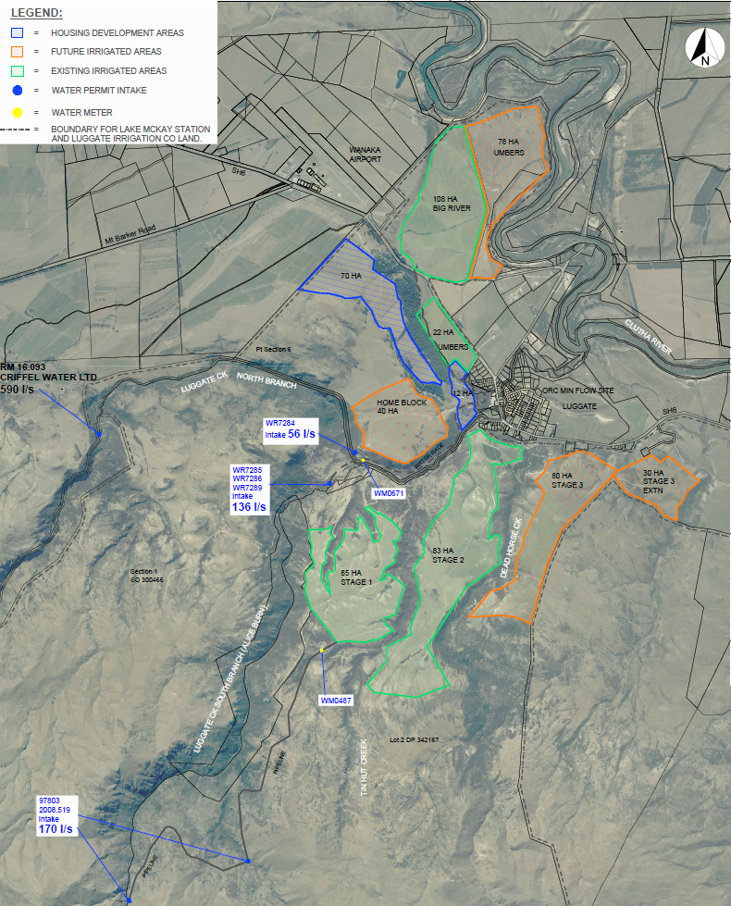

**Figure 1: Location of the points of take, water metres (yellow dot) current irrigation areas, future irrigation areas, and housing development areas (Source: Application)**

**WR7284, WR7285, WR7286 and WR7298:**

The Luggate Irrigation Limited intake is through a surface water take from the Alice Burn and an additional take from the North Branch of the Luggate Creek. These are combined into one race which measures the combined take (Figures 2-4). The water race flows above Luggate Creek to supply a storage pond beside Highway 6. The race has a capacity of 200 l/s but currently loses 30 l/s via control systems back to Luggate Creek.

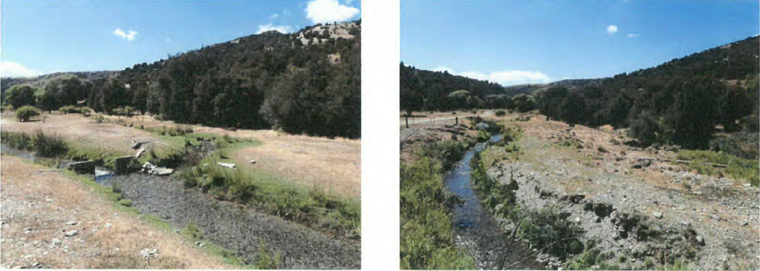

**Figure 2: Water race for WR7285 and WR7298 (takes from the Alice Burn). (Source: Compliance inspection sheet).**

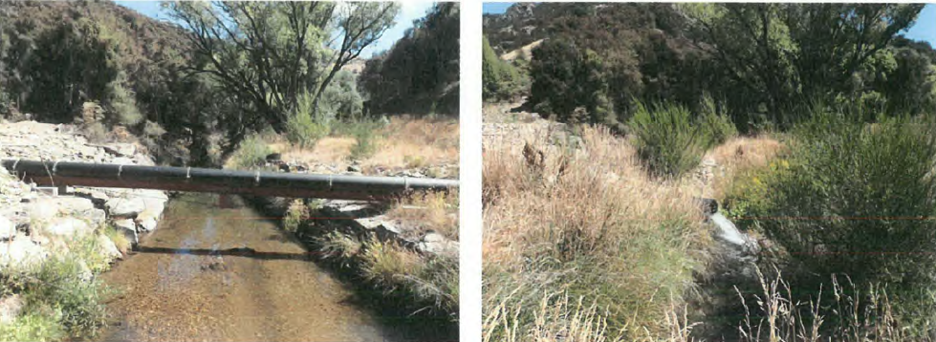

**Figure 3: Piped race for WR7285 and WR7298 the race enters a pipe over Luggate Creek to join the take from Luggate Creek. (Source: Compliance inspection sheet).**

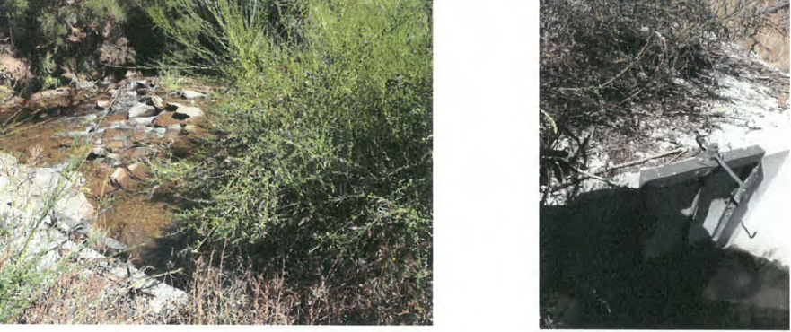

**Figure 4: The take location for WR7284 and WR7286 from the Luggate Creek. (Source: Compliance inspection sheet).**

**97803 and 2008.519:**

The Lake McKay takes are high up in the Alice Burn and the water flows through a pipe for 4 km to the Lake McKay terraces where it powers a K-line system under gravity, the pipeline has a capacity of 200 l/s (Figure 5-7).

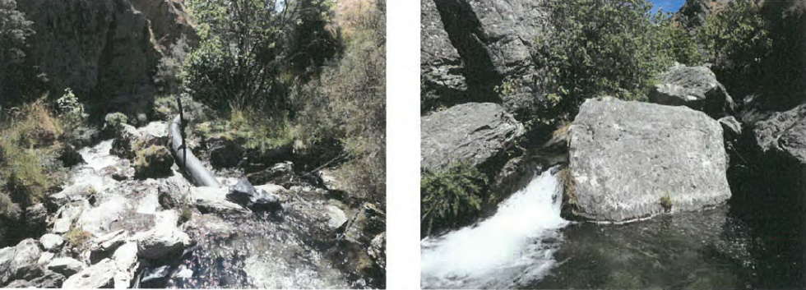

**Figure 5: 2008.519 and 97803 intake Alice Burn. (Source: Compliance inspection sheet).**

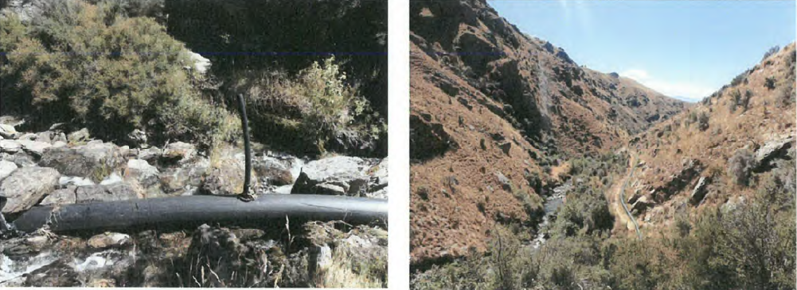

**Figure 6: Main intake for 2008.519 and 97803 and pipeline to overflow tank. (Source: Compliance inspection sheet).**

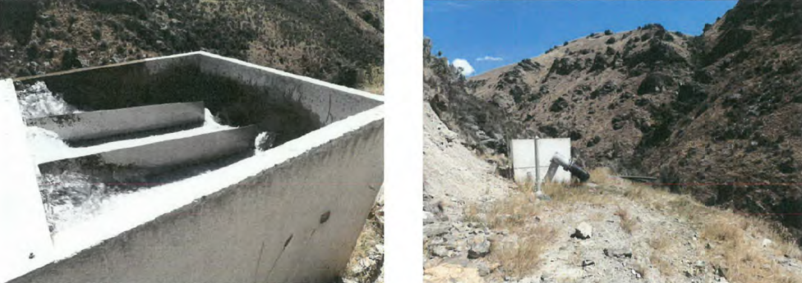

**Figure 7: The overflow tank for 2008.519 and 97803 – the overflow goes back into the Alice Burn. (Source: Compliance inspection sheet).**

**3. Section 104 Evaluation**

**3.1 S104(1)(a) – Actual and potential effects on the environment of allowing the activity**

Section 104(1)(a) of the RMA requires the council to have regard to any actual and potential effects on the environment of allowing the activity. This includes both the positive and the adverse effects.

As a restricted discretionary activity, the Council must disregard an adverse effect of the activity that does not relate to a matter for which a rule or national environmental standard restricts discretion.

**Adverse effects**

In considering the adverse effects, the Consent Authority:

* may disregard those effects where the plan permits an activity with that effect; and
* must disregard those effects on a person who has provided written approval.

Having regard to the planning framework as set out in the body of this report, it is considered that the adverse effects of the activity on the environment that need to be assessed relate to:

* Allocation availability both primary and supplementary
* Minimum flows
* Instream values
* Downstream users and competing demand for water
* Rate, volume, timing and frequency of take of water being taken and used

**3.1.1 Primary and Supplementary Allocation**

The Council was able to reduce the allocation in the catchment down to 785 L/s from 1024 L/s through assessments of historic and efficient use. This caused a significant drop in primary allocation for both parties. The applicants have since able to come to an agreement of primary allocation for the catchment with the addition of supplementary use for both takes which brings the overall primary allocation sought down to 538 L/s. This is close to the primary allocation in the Regional Plan Water that has been established for the Luggate Creek. The approach of adding supplementary takes allows the applicants to have access to water for future development whilst providing for instream values and being consistent with the NPS-FM and policies within the Regional Plan Water.

Primary allocation is defined by Policy 6.4.2 of the RPW:

*“ To define the primary allocation limit for each catchment, from which surface water takes and connected groundwater takes may be granted, as the greater of:*

*(a) That specified in Schedule 2A, but where no limit is specified in Schedule 2A, 50% of the 7-day mean annual low flow; or*

1. *The sum of consented maximum instantaneous, or consented 7-day, takes of:*
2. *Surface water as at: 19 February 2005 in the Welcome Creek catchment; or 7 July 2000 in the Waianakarua catchment; or 28 February 1998 in any other catchment; and*
3. *Connected groundwater as at 10 April 2010,*

*less any quantity in a consent where:*

1. *In a catchment in Schedule 2A, the consent has a minimum flow that was set higher than that required by Schedule 2A.*
2. *All of the water taken is immediately returned to the source water body.*
3. *All of the water being taken had been delivered to the source water body for the purpose of the subsequent take.*
4. *The consent has been surrendered or has expired (except for the quantity granted to the existing consent holder in a new consent).*
5. *The consent has been cancelled (except where the quantity has been transferred to a new consent under Section 136(5).*
6. *The consent has lapsed.”*

The total theoretical primary allocation of the Luggate catchment is 500 L/s. The existing primary allocation of the Luggate catchment (i.e. calculated in accordance with Policy 6.4.2(b)) equates to 1,024 L/s. As these takes already form part of the allocation reducing the takes from 424L/s to 180 L/s puts 244 L/s back into the allocation. Therefore, the primary allocation of the Luggate catchment with the reduced allocation of this application and the Criffel application is 538L/s. The applicants have come to this primary allocation for the catchment through substituting current primary allocation with supplementary allocation.

The effect of the allocation being beyond the numeric threshold means the river will sit at the minimum flow for longer, (See Appendix 4) the minimum flow ensures the river will not fall below this number and dry out, flow variability will still be expected during rainfall events. As such the effect of the allocation limit being exceeded in this case is no more than minor.

Supplementary allocation is provided for by Policy 6.4.9 of the RPW. The policy enables access to water at moderate flows (although flows are considerably higher in over-allocated catchments), whilst maintaining the aquatic ecosystem and natural character values of affected rivers, and providing for natural flow variation:

*6.4.9 To provide for supplementary allocation for the taking of water, in blocks of allocation where that is appropriate:*

*(a) Such that up to 50% of flow at the catchment main stem, minus the assessed actual take, is available for allocation subject to a minimum flow set to ensure that no less than 50% of the natural flow remains instream; or*

*(b) On an alternative basis, provided:*

1. *The take has no measurable effect on the flow at any Schedule 2 monitoring site, or any site established in terms of Policy 6.4.4, at flows at or below any minimum flow applying to primary allocation; and*
2. *Any adverse effect on any aquatic ecosystem value or natural character of the source water body is no more than minor; and*
3. *There is no adverse effect on any lawful existing take of water.*

*(c) Supplementary allocations and associated minimum flows for some catchments are set in Schedule 2B.*

The allocation block under Policy 6.4.9(a) is calculated using Method 15.8.1A.1 of the RPW and is based on the 7-day mean annual low flow of the catchment. This method also allows for water to remain instream, to provide for aquatic ecosystems and natural character.

The combined primary allocation block of the Luggate catchment sought by the two applicants is538 L/s, therefore, using Method 15.8.1A.1,up to 250 L/s in the first supplementary block calculated under Policy 6.4.9 if the flow monitoring site at State Highway 6 is 788 L/s. Up to 250 L/s in the second supplementary block is available to be taken when the monitoring site State Highway 6 is flowing at 1038 L/s. Figure 5 below shows the available supplementary blocks for the Luggate Catchment with the primary allocation as sought at 538 L/s and the coupled with the 180 L/s minimum flow.

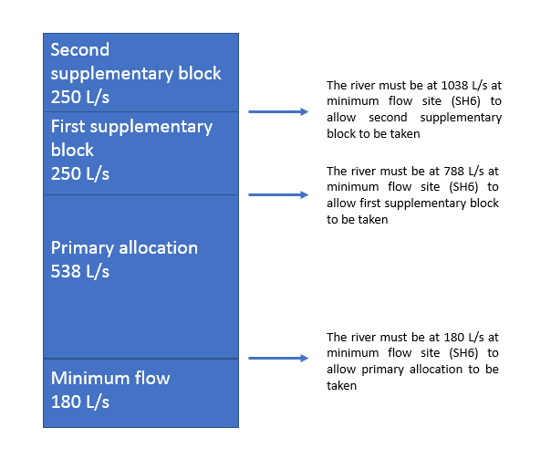

**Figure 8: Supplementary and primary allocation blocks within the Luggate Catchment.**

The applicant has applied for 80 L/s in the first supplementary block and 86 L/s in the second supplementary block shown in Table 1 below. The proposed use of the supplementary blocks will have a no more than minor effect on the catchment. The proposed use of the supplementary blocks will have a no more than minor effect on the catchment. As discussed in the Science assessment in Appendix 4, the proposal is not expected to result in prolonged periods of flat-lining, with flow variability largely mimicking that expected in the absence of abstraction, albeit with a lower baseflow than the natural flow regime. The main effect of the proposal is to reduce the amount of water taken at low flows (thereby resulting in higher flows than currently observed) but increasing the amount of water that is taken as flows recede from high flows. This represents an improvement in in-stream habitat availability and will significantly reduce the length of time that the river is held at low flows compared with the existing abstraction regime. The minimum flow (180 l/s) will be the primary determinant of habitat availability in Luggate Creek for juvenile trout. Therefore, taking water as supplementary allocation is expected to have a no more than minor effect.

**Table 1: Luggate Catchment allocation blocks**

|  |  |  |  |  |
| --- | --- | --- | --- | --- |
| **Allocation Block** | **Current Allocation from Flow Blocks** | **Water Take applied for by Applicants** | **Minimum Flow Restriction**  **Level** | **Remaining Allocation** |
| **Criffel Primary** | 601.8 l/s | 358 l/s | 180 l/s | Fully Allocated |
| **LIC/LM Primary** | 423 l/s | 180 l/s | 180 L/S | Fully Allocated |
| **Primary Total** | 538 l/s | 538 l/s | 180 l/s | Fully Allocated |
| **1st Supplementary** | Nil | 250 l/s | 788 l/s | Fully Allocated |
| **2nd Supplementary** | Nil | 166 l/s | 1038 l/s | 84 l/s |
| **Total Takes** |  | **954 l/s** |  |  |

**3.1.2 Minimum Flow**

Minimum flows may be set for a river or catchment for the purpose of restricting when primary allocation takes of water may not be exercised. A minimum flow provides for the maintenance of aquatic ecosystem and natural character values of water bodies, while providing for the sustainable taking of water for use. Once set in Schedule 2A of the RPW, they are imposed on all relevant consents in that catchment. When a minimum flow is breached, all consents to take water as primary allocation (with some exceptions), must cease.

As this take is primary allocation from the Luggate catchment,any consent granted will be subject to the minimum flow set in Schedule 2A of the RPW of 180 L/s (1 November to 30 April) and 500 L/s (1 May to 20 October) at the State Highway 6 monitoring site.

**3.1.3 Effects on Fish and Instream Values**

With regard to the effects on the instream values of a surface water body, only the following can be considered under the restricted discretionary considerations listed by Rule 12.1.4.8:

* the need for a residual flow at the point of take;
* the rate, volume, timing and frequency of water to be taken and used;
* the proposed methods of take;
* the need to prevent fish entering the intake and to locate new points of take to avoid adverse effects on fish spawning sites; and
* any effect on any Regionally Significant Wetland or on any regionally significant wetland value.

In addition to a minimum flow, a residual flow may be set at the point of take, for the purpose of providing for instream values of the source water body. As outlined in Appendix 4 Dean Olsen from Ryder Environmental has assessed that Luggate Creek and the Alice Burn have instream values.

In Appendix 4 Mr Olsen has assessed the need to prevent fish entering the intake and to locate new bywash points to avoid adverse effects on fish spawning sites. The applicants proposed fish screen will allow the use of the race as spawning habitat for trout whilst also ensuring effects on fish will be no more than minor. Mr Olsen’s recommendations regarding fish screening have been included in the proposed consent conditions in Appendix 6.

There are no Regionally Significant Wetlands or any known regionally significant wetland values that will be affected by the proposed water take. Therefore, there are no effects on Regionally Significant Wetlands.

**3.1.4 Effects on Other Water Users**

There are no downstream users from the take and there is a minimum flow on Luggate Creek. There is one upstream user, Criffel who have applied to replace their deemed permits. As a decision on Criffel is being made first and then this consent may exist as part of the environment by virtue of being granted, the new Criffel water permit may be part of the environment. However, as the take is upstream there is no considered to be any effects that are more than minor on this permit.

Criffel’s current deemed permits do form part of the existing environment, the deemed permits do not need to adhere to a minimum flow therefore, the effect on Criffel Water Limited is no more than minor.

**3.1.5 Rate, volume, timing and frequency of water being taken and used**

The water take for the Lake McKay permit will be via the point of take in the Alice Burn Branch of the Luggate which is subsurface gravel gallery intake to a gravity fed pipeline. The 4km pipeline, which replaced an open water race, feeds a K line irrigation scheme.

The Luggate Irrigation Company take is from the Alice Burn and the north branch of Luggate Creek. Both points of take are directed into a water race which carries the water to the Umbers block and the Big River irrigation pond on the other side of Highway 6. On the Big River block the irrigation method is centre pivot and K line on the peripheral areas. On the Umbers Block the irrigation method is surface contour and is being upgraded to K Line.

The volume of water being used to irrigate the current 298 hectares is inefficient. The applicant states that approximately 200 L/s would allow the land to be irrigated efficiently. However, the current take is 291 L/s. Therefore the water is not being used efficiently.

However, the means and timing of the take, and the rate at which water now proposed to be taken in the amended aplication, described in Section 2 of this report, are not anticipated to have any adverse effects on instream values. The lower primary allocation instantaneous rate will ensure the applicant has to efficiently irrigate the land. Therefore, effects of the proposed rate of take are considered to be no more than minor.

The addition of supplementary allocation enables the future development of the land. The applicant has proposed the supplementary allocation be able to be taken year-round to ensure the water can be utilised for storage. As the supplementary take will ensure that values within the streams are protected the effect of the year round taking is assessed as no more than minor.

**3.1.6 Positive Effects**

The proposal will have the following positive effects:

* Reduction in consented rates of takes from what has been previously authorised with overall positive effects on flows and instream values, compared with the current situation;
* Economic well-being of the farming operation and flow-on effects from this on the local economy and community;
* Social benefits by supporting the families and workers who directly rely on the farm
* Provides greater certainty for the farming production than is possible with dryland faming
* Maintenance of pasture quality over a critical dry period/crops are not affected by moisture stress at critical growing times
* Conversion to more efficient application methods proposed, which will minimise losses of water

**3.2 S104(1)(ab)**

We are not aware of any specific offset or compensation proposal provided by the applicant at this stage.