**Proposed Plan Change 6AA**

**Regional**

**Plan: Water**

**for Otago**

**Incorporating the Decisions of Council**

**ISBN: 978-0-908324-58-3**

|  |  |
| --- | --- |
|  | **8 February 2020** |

***Note:***

*The base document for this plan change is the Regional Plan: Water for Otago (operative 1 July 2018). All amendments to text in this Plan resulting from Proposed Plan Change 6AA as notified, and incorporating Council Decisions, are shown with additions underlined and deletions ~~struckout~~****~~.~~***

7

Water  
Quality

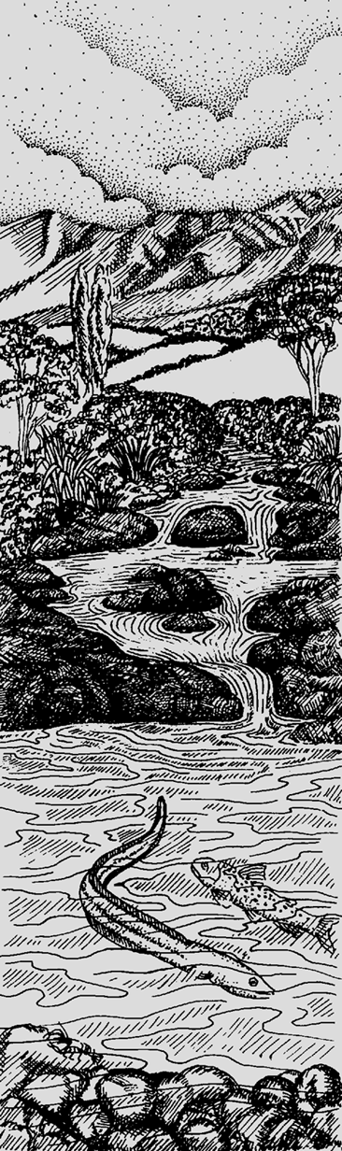

7.A to 7.C 7.1 to 7.5 *[Unchanged]*

7.A to 7.C *[Unchanged]*

7.D Policies for discharges of water and contaminants, excluding those discharges provided for in 7.C

7.D.1 *[Unchanged]*

7.D.2 Schedule 16 discharge thresholds apply to permitted activities, from 1 April 2026 ~~1 April 2020~~, at or below the reference flows set in Schedule 16B based on median flows.

7.D.3 to 7.D.5 *[Unchanged]*

12

Rules: Water Take,

Use and Management

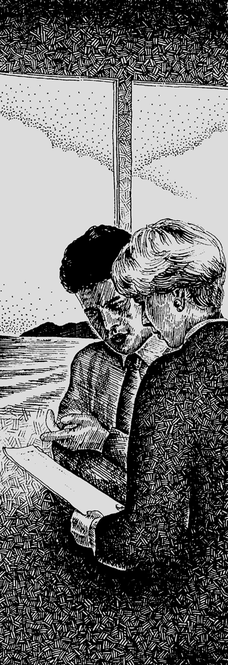

12.0 to 12.3 *[Unchanged]*

12.A to 12.B *[Unchanged]*

12.C Other discharges

12.C.A General Rules for section 12.C *[Unchanged]*

12.C.0 Prohibited activities: No resource consent will be granted *[Unchanged]*

12.C.1 Permitted activities: No resource consent required

12.C.1.1 The discharge of water or any contaminant to water, or onto or into land in circumstances which may result in a contaminant entering water, is a ***permitted*** activity, providing:

(a) to (f) *[Unchanged]*

(g) From 1 April 2026 ~~1 April 2020~~, the discharge also complies with 12.C.1.1A.

Figures 5 to 7: *[Unchanged]*

12.C.1.1A From 1 April 2026 ~~1 April 2020~~, in addition to Rule 12.C.1.1, when the water flow at the relevant representative flow monitoring site is at or below the reference flow in Schedule 16B, the following conditions apply:

(a) to (c) *[Unchanged]*

Figures 8 to 13: *[Unchanged]*

12.C.1.2 *[Unchanged]*

12.C.1.3 The discharge of nitrogen[1] onto or into land in circumstances which may result in nitrogen entering groundwater, is a ***permitted*** activity, providing:

(a) From 1 April 2026 ~~1 April 2020~~, the nitrogen leaching rate does not exceed:

(i) to (iii) *[Unchanged]*

(b) (i) From 1 May 2014 to 31 March 2026 ~~31 March 2020~~, the landholder for outdoor pork, fruit (excluding grapes), berry and rotational vegetable production will keep a record of all inputs into the farm system and evidence that practices complied with the relevant industry good management practices and provide Council upon request with that information. From 1 April 2026 ~~1 April 2020~~, 12.C.1.3(b)(ii) will apply; and

(ii) *[Unchanged]*

12.C.2 Restricted discretionary activities: Resource consent required *[Unchanged]*

12.C.3 Discretionary activities: Resource consent required *[Unchanged]*

20

Schedules



16 Schedule of permitted activity discharge thresholds for water quality

Schedule 16 describes the thresholds that apply to discharges permitted under Rule 12.C.1.1A in the catchments of each discharge threshold area. Discharge Threshold Areas 1 and 2 catchments are shown on the J-series Maps.

16A Permitted activity discharge thresholds for water quality by discharge threshold area

|  |  |  |  |  |
| --- | --- | --- | --- | --- |
| **Discharge Threshold Area 1 Catchments** | **Nitrate-nitrite nitrogen** | **Dissolved reactive phosphorus** | **Ammoniacal nitrogen** | ***Escherichia coli*** |
| **Timeframe** | 1 April 2026 ~~2020~~ | | | |
| * **Catlins** * **Careys Creek** * **Kaikorai** * **Leith** * **Mokoreta** (within Otago) * **Owaka** * **Pomahaka**, downstream of Glenken * **Tahakopa** * **Tokomairiro** * **Tuapeka** * **Waitahuna** * **Waitati** * **Waiwera** * Any unlisted tributary on the true right bank of the **Clutha/Mata-Au**, south of Judge Creek * Any unlisted tributary on the true left bank of the **Clutha/Mata-Au**, south of the Tuapeka * Any unlisted catchment that discharges to the **coast**, south of Taieri Mouth | 3.6 mg/l | 0.045 mg/l | 0.2 mg/l | 550 cfu/100 ml |

|  |  |  |  |  |
| --- | --- | --- | --- | --- |
| **Discharge Threshold Area 2 Catchments** | **Nitrate-nitrite nitrogen** | **Dissolved reactive phosphorus** | **Ammoniacal nitrogen** | ***Escherichia coli*** |
| **Timeframe** | 1 April 2026 ~~2020~~ | | | |
| * **Cardrona** * **Clutha/Mata-Au** (above Luggate) * **Clutha/Mata-Au** and any unlisted tributary (Luggate to mouth, including Lake Roxburgh, and excluding tributaries described in Discharge ThresholdCatchment Area 1) * **Fraser** * **Kakanui** * **Kawarau** * **Lake Dunstan** * **Lake Hayes** * **Lake Hawea** and any tributary * **Lake Johnson** * **Lake Onslow** * **Lake Tuakitoto** * **Lake Waipori** & **Waihola** * **Lake Wakatipu** and any tributary * **Lake Wanaka** and any tributary * **Lindis** * **Luggate** * **Manuherikia** * **Mill Creek** (tributary to Lake Hayes) * **Pomahaka**, upstream of Glenken * **Shag** * **Shotover** * **Taieri** * **Trotters** * **Waianakarua** * **Waikouaiti** * **Waipori** * **Waitaki** tributaries within Otago * Any unlisted catchment that discharges to the **coast**, north of Taieri Mouth | 1.0 mg/l | 0.035 mg/l | 0.2 mg/l | 550 cfu/100 ml |

mg/l = milligrams per litre

cfu/100 ml = colony-forming units per 100 millilitres

1. For the purpose of Rule 12.C.1.3, nitrogen comprises of organic nitrogen, ammoniacal nitrogen, nitrite nitrogen and nitrate nitrogen forms.